1. Software Engineering
Systematic, disciplined, quantifiable approach to development, operation, and maintenance of software.
SE = people + process + code over time
Aspect | CS | Programming | SE
Goal | Theory | Produce Code | Evolving Product
Time | Timeless | Short-Lived | Long-term
Team Scale | Solo / Lab | Solo / Pair | Multi-Person/  Stakeholder
Why SE is Hard: (Software Crisis)
cost overruns & failures, global cost of poor software quality ≈ US $2.4 trillion (2022).
No Silver Bullet:
No single tech/management change can give 10× productivity or reliability.
Essential complexity – inherent to understanding & specifying the problem.
Accidental complexity – from tools, languages, environments (e.g., buffer overflows).
Examinable link: generative AI may cut accidental complexity, but essential remains.
Core SE activities:
1. Specification – define functionality & constraints.
2. Development– produce software.
3. Validation – ensure it meets stakeholder needs.
4. Evolution – adapt to change post-release.
“Shift-Left”- Fixing defects earlier (requirements/design) is far cheaper than in maintenance.
Plan-driven Waterfall: linear phases, clear spec, change-averse.
Agile rise → Scrum, Kanban
People as first-order components:
Cockburn study: project success correlated more with people factors than methodology weight.
Attributes of great engineers (Microsoft study): improving, passionate, sees forest & trees, creates shared context, designs elegant solutions.
3. SE Processes
Plan Driven Vs Agile:
Dimension | Plan-Driven | Agile
Requirements | Fixed upfront | Evolving
Documentation | Comprehensive | “Just enough”
Control | Predictive | Adaptive
Delivery | Big Bang or Staged | Frequent Increments
Change Cost Curve | Steep | Flatter
Agile Manifesto:
1. Individuals & interactions over processes & tools
2. Working software over comprehensive documentation
3. Customer collaboration over contract negotiation
4. Responding to change over following a plan
Twelve Agile Principles:
Customer satisfaction through early & continuous delivery
Welcome changing requirements
Deliver frequently (weeks)
Dev & business daily together
Support motivated individuals
Simply face-to-face is best
The primary measure is working software
Constant sustainable pace
Leverage technical excellence & good design
Embrace simplicity (maximise work not done)
Resilient self-organising teams
Sprint reflection & tuning
Lean & Product Development:
New New Product Development Game- Cross-functional, overlapping phases, rugby-“scrum” metaphor
Toyota Production System- pull flow, Kanban Cards, Jidoka, Kaizen
Scrum Artifacts:
Product Backlog + Product Goal
Sprint Backlog (Goal, PBIs, plan)
Increment + “Definition-of-Done” agreement
Kanban Metrics: lead time, cycle time, throughput, cumulative-flow diagram.
Extreme Programming Practices: Test-Driven Development, Pair Programming, Collective Code Ownership, Continuous Integration, Simple Design & Refactoring, On-site Customer, Sustainable Pace.
Scaling Frameworks:
SAFe, Scrum@Scale, Nexus, LeSS, Spotify model
DevOPS: 1. Flow – small batches, fewer hand-offs, CI/CD pipelines.
2. Feedback – monitoring, alerting, DORA metrics (lead time, deployment freq, change-fail %, MTTR)
3. Continuous Learning & Experimentation – blameless post-mortems, A/B, chaos-engineering
CI/CD automation, Infrastructure-as-Code, Observability, Value-Stream Mapping.
4. Requirements Engineering
Discovering, analysing, documenting, checking services + constraints a system must meet.
Wicked-Problem Nature → no definitive scope, one-shot, unique, conflicting views, no single test for “done”.
Cost of error – defects injected in RE cost ×10–200 more to fix later; Deloitte & Google SRE books cited.
Functional (What the System do) – Stakeholders concentrate here, Multiple Architectures possible
Non-Functional (Quality Attributes) - Often implicit, can conflict, drive architecture. Must be measurable.
Quality Attribute Scenario (QAS) template - <Source, Stimulus, Artifact, Environment, Response, Response-measure> – learn the six slots; availability
Quality Attributes: Availability, Performance, Modifiability, Deployability, Energy efficiency, Security
Stakeholder Identification: Anyone who influences / Is impacted.
Baseline list → expand their network (snowball).
Technique | Strength | Caveat
Interviews | Rich Detail | Bias, Limited scale
Workshops | Resolve Conflicts fast | Resource Heavy
Questionnaires | Large Populations | Closed-Ended
Observation | Uncover Implicit reqs | Time-Consuming
Prototyping | Visualize unclear UI | Risk “Prototype-scope creep”
Personas | Keep User in discussions | Assumption Driven
Validation Techniques:
Informal reviews (desk-check, passaround, walkthrough)
Formal inspections – roles, checklist; highest defect removal leverage.
Feasibility study – early 3-question mini-project.
Prototyping – change anticipation.
Acceptance tests / conditions of satisfaction (agile).
Change & Requirements Management:
Plan items: ID scheme, change-impact analysis workflow, traceability policy, tool support.
Trace links: Req ↔ design ↔ code ↔ test enables impact calc.
5. Modelling
Create abstractions that help (a) derive/clarify requirements, (b) communicate design, (c) reason about quality attributes before code exists.
Abstraction ≠ representation – we deliberately leave out detail to focus thinking.
Perspectives & Examples:
External (System ↔ environment boundary) MRT map around Laksa stall.
Interaction (Message flow between comps/actor) HTTP request sequence
Structural (Static organisation of elements) Class or container diagram
Behavioural (Dynamic response to events) State machine of microwave.
Class | Static Structure | show attributes (+/– type), associations/multiplicity
Sequence | scenario messages | actor/object lifelines, asynchronous vs. return arrow
Activity | workflow/parallelism | initial/end nodes, branch/merge diamonds
State Machine | event-driven behaviour | labelled transitions, super-state
Use-Case | requirements scope | actors outside system boundary
C4:
System Context – people & neighbouring systems
Container – runtime deployables (web app, DB, broker)
Component – breakdown of one container (often optional)
Software Architecture:
“Set of structures (elements + relations + properties) needed to reason about the system” (Bass).
Significant decisions: those whose cost to change is high.
Architecture vs detailed design: architecture = the 10 % “important stuff” that constrains the rest.
Architecture Drivers (ASR): Mostly non-functional requirements.
Attribute-Driven Design: 1. Gather ASRs. 2. Set iteration goal (subset of ASRs). 3. Choose part of architecture to refine. 4. List candidate patterns/tactics/components. 5. Instantiate chosen solution in context. 6. Record decisions (views, notes) 7. Analyse against goal; repeat until “good enough”.
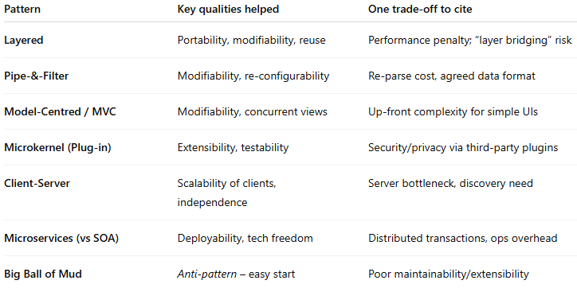
Architectural Tactics: Availability:
Detect: Heartbeat, sanity check, system monitors
Prepare/Repair : redundant spare, rollback, in-service upgrade
Reintroduce : shadow mode, escalating restart
Prevent : remove from service, ACID transactions, increase competence set (e.g., SQLite)
Performance:
Manage work request rate (sampling, back-pressure)
Limit event response (drop or queue)
Maintain multiple copies (replication, caching, RAID)
Schedule resources (FIFO, priority, round-robin)
Conway’s Law (organisation ↔ architecture)
“Design mirrors communication structure.”
Useful to justify team-structure decisions and why refactoring architecture may require org change.
Monolith vs Modular Mono. Vs Microservices
Know definitions, pros/cons, and that microservices aim for acyclic service deps + “two-pizza team” rule.
6. Software Testing
Verification (Building it right) Unit/system tests vs. spec
Validation (Building the right thing) User-story/UAT scripts
Test Oracle: mechanism telling pass/fail → can encode functional or non-functional property (e.g., assertTimeout, perf budget)
Pesticide Paradox: “Every method leaves a residue of subtler bugs the method misses.”
Therefore mix levels + techniques; exam may ask you to pick two complementary kinds for a scenario.
Testing Levels:
Unit - single func/class, logic, off-by-one.
Integration - comp ↔ comp, protocol/api mismatch
System/E2E - full stack, env/config bugs.
Flaky Tests:
1. Concurrency races
2. Async wait without proper sync
3. Order-dependent state / leaking resources
V-model: parallel to each upstream phase; UAT after build. Plan-driven, late feedback
TDD (XP): write failing test first, red-green-refactor loop (5 steps) Drives design, shifts left.
Black Box Testing Workflow:
1. Understand requirements
2. Explore system (mental model)
3. Partition inputs/outputs (equivalence classes)
4. Analyse boundaries – on-/off-point tests
5. Devise minimal but adequate cases
6. Automate in unit framework
7. Augment with creativity/experience
Boundary-value analysis ⇒ off-by-one killers; be able to give string length 1 vs 2 sample.
White Box Testing & Coverage Criteria:
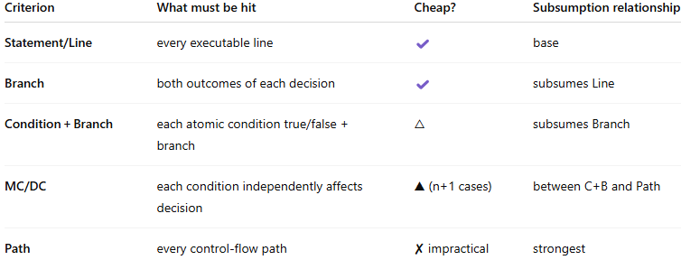
MC/DC = (Conditions Independently Demonstrated / Total conditions in the decision) * 100%
Mutation Testing: (e.g. PITest (java))
Mutant = program with a tiny syntactic change
Killed when at least one test fails; else it survives → indicates gap.
Mutation score = (killed / total) × 100 %.
Pitfalls: equivalent mutants (no behavioural change) & high compute cost.
8. Debugging
35-50 % of dev time; 50-75 % of total project cost goes to debugging/validation
shorten time-to-diagnosis by replacing ad-hoc “poke & pray” with repeatable strategies
Mistake → Defect (bug) → Fault (incorrect state reached) → Failure (externally visible)
Scientific Method:
1. Question (Why does input X fail?)
2. Hypothesis (suspect variable/tag state)
3. Prediction (if hypothesis true, assert Y will be false)
4. Experiment (run, observe)
5. Refine/Repeat until coherent diagnosis reached — then fix.
Tools:
Printf / Logging: (language-agnostic, quick),
(noisy, can forget removal)
Debugger: (precise state view), (requires IDE, still ad-hoc)
logging levels (DEBUG, INFO, WARN, ERROR, FATAL).
Program Slicing:
Slice = subset of code that can influence a variable at a location
Uses Program Dependence Graph (data + control edges).
Static Slice - all possible executions, pre‑commit reasoning.
Dynamic Slice - only the observed execution, post-failure debugging
Forward/Backward - what uses / what defines value, impact vs. cause.
Statistical Fault Localisation (SFL):
Use many test executions; correlate coverage with pass/fail outcome.
Tarantula:
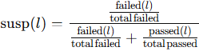
Assign 0 if denominator zero. Highest score ⇒ inspect first.
Red = 1.0, Yellow ≈ 0.5, Green ≈ 0.0 – know how to translate susp to colour.
Correlation ≠ causation; experts still need reasoning; IDE adoption low.
Test-Case Reduction:
Most bugs manifest with simple inputs → strive for minimal failing case.
Delta Debugging: (e.g. creduce)
1. Start with failing input c✘.
2. Partition into n chunks Δᵢ and complements ∇ᵢ.
3. If any Δᵢ fails, recurse on it; else if any ∇ᵢ fails, recurse there; else increase granularity.
4. Stop when 1-minimal (no subset fails).
Regression Bug Localization:
Something worked in version v₀ (good) and fails in vₙ (bad).
git bisect start → mark good & bad commits → optional git bisect run test.sh for automation. Log₂(N) builds tested.
After first-bad commit found, treat hunks as elements and apply ΔDebug to isolate offending lines.
Rubber-Ducking: Explain problem aloud → reforms hypotheses, cheap sanity check. Mentioned as low-tech but powerful.
10. Software Development Practices
Centralised vs. Decentralised: ease of auditing vs. offline work.
Principles
1. Consistency ≫ Optimality
2. Code must be clear and unsurprising; practical beats clever.
3. Auto-formatter mandatory for whitespace/brace rules.
Style guide covers formatting + idioms + naming conventions.
Versioning: Assigning identifiers to bundles of software so users & devs can reason about what’s running.
GitFlow: long-lived develop + release/hotfix branches good for slower cadence.
Trunk-based: everyone merges to main behind feature flags favours CI/CD.
Dependencies = libs, build tools, external services, containers.
Hell scenario: transitive version conflicts.
Deprecation: Planned Removal
Software Quality Assurance (SQA): SQA ≠ testing, it’s all activities to ensure product quality pre-release.
11. Static Analysis
Static analysis ≜ reasoning about code without running it. Finds whole classes of bugs earlier, improves maintainability, shortens debug cycles.
Linters / style checkers - Non-semantic; enforce conventions (ESLint, flake8)
Control-flow analysis - Over-approximates possible call orders (Call-graph construction)
Data-flow analysis - Works with lattices; detects dead stores (Live-variable, reaching-defs)
Type checking - Proves mismatch errors impossible (Java/C# compilers, Flow, TS)
Type system = tractable syntactic method for proving absence of certain behaviours
ill-typed ⇒ impossible to run safely
Sound: Never accepts a program that can “go wrong”.
Complete: Accepts all safe programs.
Impossible for Turing-complete PL; we trade completeness for decidability
Simply-Typed λ-Calculus (STLC)
Types: τ,σ ::= T | σ → τ (base or arrow)
Terms: x | λx:σ.M | M N (identical to untyped)
Variable: Γ,x:τ ⊢ x : τ
Abstraction: Γ,x:σ ⊢ M:τ ⇒ Γ ⊢ λx:σ.M : σ→τ
Application: Γ ⊢ M:σ→τ, Γ ⊢ N:σ ⇒ Γ ⊢ M N : τ
Preservation: M:τ ∧ M→M′ ⇒ M′:τ
Progress: M:τ is either a value or can step.
Strong normalisation: every well-typed term terminates shows completeness is impossible.
Reduction Rules: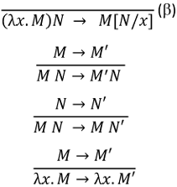
12. Advanced Software Testing
widen bug-finding beyond hand-written, example-based unit tests; humans supply ideas, tools supply many inputs/oracles automatically.
Property-Based Testing (PBT)
state properties that must hold for all inputs; framework searches for a counter-example
1. Input generator (default or custom)
2. Property oracle — Boolean predicate over input/output
3. Shrinker — reduces failing cases to minimal repro
Strengths: high leverage on mathematically defined components; communicates spec.
Weaknesses: needs developer creativity to craft good properties; poor for purely side-effect behaviour.
Differential Testing:
Idea: Run the same input on ≥2 independent implementations/configurations; flag divergences
Csmith vs multiple C compilers (hundreds of bugs)
Randomised SQL cores across SQLite/MySQL/Postgres
Pitfalls: functional overlap may be small → false alarms; multiple systems may share the same bug; non-deterministic outputs; hard to craft valid inputs for UB-prone languages
Metamorphic Testing (MC)
1. Source test case I and observed output O
2. Metamorphic relation (MR) expresses how a transformed input I′ should change output O′
Strength: needs only one SUT; powerful where MRs exist.
Weakness: inventing good MRs can be hard; relation must be checked automatically.
Symbolic Execution & Execution Trees:
Treat some variables as symbols (α, β, γ) and explore all feasible program paths without enumerating concrete inputs.
1. Maintain symbolic state σ mapping vars→expressions
2. At each branch, fork with updated path constraint
3. Use SMT solver to test PC feasibility; infeasible → prune
4. Solve PC to obtain concrete test inputs.
Constraint Solvers:
SAT: purely Boolean CNF; NP-complete yet practical (MiniSAT)
SMT: SAT + theories (ints, arrays, bit-vectors)

